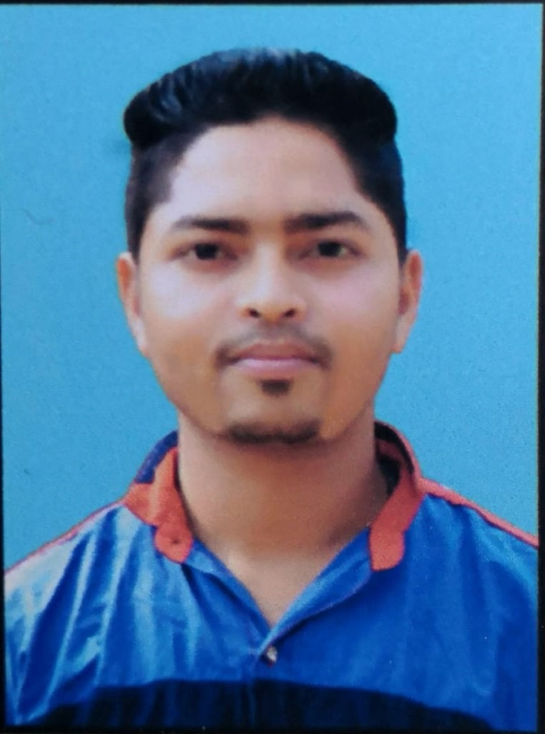

Binod Kumar

Durbarani Gaon, Barpathar

P.O.- Barpathar, Dist.- Golaghat(Assam), 785602

DOB: 20/07/1995

Phone: +91 7002713195

E-mail: [binodkumar45456@gmail.com](mailto:binodkumar45456@gmail.com)

Carrier Objective

To secure a position where I can efficiently contribute my skills and abilities to the growth of the organization and build my professional career.

Personal Qualities

* Ability to work under pressure.
* Strong motivational and leadership skill.
* Ability to work individual as well as team.
* Good Communication Skill
* Good Management Skill

Academic Qualification

|  |  |  |  |  |
| --- | --- | --- | --- | --- |
| **Qualification** | **Year of**  **Passing** | **University/**  **Board** | **College/School** | **Percentage** |
| **ITI (Diesel Mechanic)** | 2018 | NCVT | ITI , Bongaigaon | 80.38% |
| **B.A** | 2018 | Dibrugarh University | Barpathar College | 47.83% |
| **H.S** | 2014 | AHSEC | Barpathar Higher Secondary School | 45.18% |
| **H.S.L.C** | 2012 | SEBA | Barpathar Higher Secondary School | 39.38% |

* **Automotive Service Technician**
  + **Duration:** 6 month
  + **Organization:** SKF, YES Centre.
  + **Place:** Kaziranga University, Jorhat
  + **Year:** 2020
* **Center for Education & Entrepreneurship Programme**
  + **Duration:** 1 Year
  + **Organization:** DRISTEE
  + **Place:** Barpathar
  + **Year:** 2017

Other Qualification

Languages Known

* English
* Assamese
* Hindi

Extra-Curricular Activities

* Playing Volleyball
* Singing
* Cricket

Declaration

I hereby declare that all the above information are correct and true to the best of my knowledge.

Date: ………………… Signature

Place: ………………… ………………………….